Exp – 10 AGGREGATING DATA, USING GROUP FUNCTIONS

Find the Solution for the following:

Determine the validity of the following three statements. Circle either True or False.

1. Group functions work across many rows to produce one result per group. True/False - TRUE

2. Group functions include nulls in calculations. True/False - FALSE

3. The WHERE clause restricts rows prior to inclusion in a group calculation. True/False – FALSE

4. Find the highest, lowest, sum, and average salary of all employees. Label the columns Maximum, Minimum, Sum, and Average, respectively. Round your results to the nearest whole number.

Ans: select round(max(salary)) as maximum,round(min(salary)) as minimum,round(sum(salary)) as sum,round(avg(salary)) as average from employees;



5. Modify the above query to display the minimum, maximum, sum, and

average salary for each job type.

Ans: select round(max(e.salary)) as maximum,round(min(e.salary)) as minimum,round(sum(e.salary)) as sum,round(avg(e.salary)) as average

from employees e

join department_1 d on d.departmentid = e.department_id

group by e.department_id;

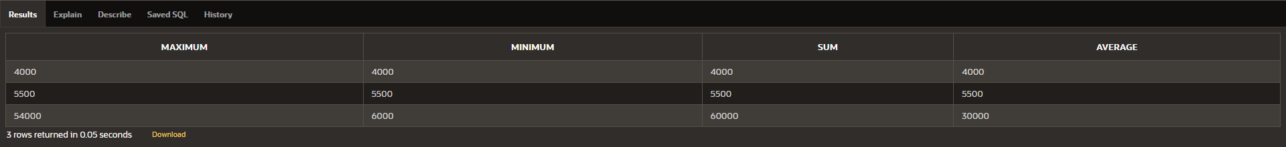

6.Write a query to display the number of people with the same job. Generalize the query so that the user in the HR department is prompted for a job title.

Ans: SELECT d.jobc , COUNT(*) AS NumberOfEmployees

FROM Employees e

join department_1 d on e.department_id = d.departmentid

group by d.jobc;



7. Determine the number of managers without listing them. Label the column Number of Managers. Hint: Use the MANAGER_ID column to determine the number of managers.

Ans: SELECT COUNT(DISTINCT MANAGER_ID) AS "Number of Managers"

FROM Employees

WHERE MANAGER_ID IS NOT NULL;



8. Find the difference between the highest and lowest salaries. Label the column

DIFFERENCE.

Ans: select max(salary)-min(salary) as difference from employees;



9. Create a report to display the manager number and the salary of the lowest-paid employee for that manager. Exclude anyone whose manager is not known. Exclude any groups where the minimum salary is $6,000 or less. Sort the output in descending order of salary.

Ans: SELECT MANAGER_ID, MIN(SALARY) AS "Lowest Salary"

FROM Employees

WHERE MANAGER_ID IS NOT NULL

GROUP BY MANAGER_ID

HAVING MIN(SALARY) > 6000

ORDER BY "Lowest Salary" DESC;



10. Create a query to display the total number of employees and, of that total, the number of employees hired in 1995, 1996, 1997, and 1998. Create appropriate column headings.

Ans: SELECT EXTRACT(YEAR FROM hiredate) AS "yearly wise employment", COUNT(*)

FROM employees

GROUP BY EXTRACT(YEAR FROM hiredate)

HAVING EXTRACT(YEAR FROM hiredate) IN (1995, 1996, 1997, 1998);



11. Create a matrix query to display the job, the salary for that job based on department number, and the total salary for that job, for departments 20, 50, 80, and 90, giving each column an appropriate heading.

Ans: select d.jobc , sum(e.salary)

from employees e

join department_1 d on e.department_id = d.departmentid

where e.department_id in (20,50,80,90)

group by d.jobc;



12.Write a query to display each department‘s name, location, number of employees, and the average salary for all the employees in that department. Label the column name-Location, Number of people, and salary respectively. Round the average salary to two decimal places.

Ans: SELECT d.jobc AS "Name", d.country AS "Location", COUNT(e.department_id) AS "Number of People", ROUND(AVG(e.Salary), 2) AS "Salary"

FROM department_1 d

JOIN employees e ON e.department_id = d.departmentid

GROUP BY d.jobc,d.country;

